Unit 6

**Group Dynamics :** Defining and classifying groups, Stages of group development, Group Properties – Roles, Norms, Status, Size and Cohesiveness, Group Decision making

Within an organization we do find number of groups. Individuals joining group (s) is a reality – may be formal or informal groups. People work in groups quite frequently and in many different areas of their life e.g. at work, school/college, sport, hobbies. The managers need to understand Group Dynamics that can enable managers to adopt the right approach of interacting with them.

**What is Group Dynamics?**

Group dynamics deals with the attitudes and behavioral patterns of a group. Group dynamics concern how groups are formed, what is their structure and which processes are followed in their functioning. Thus, it is concerned with the interactions and forces operating between groups.

Group dynamics is relevant to groups of all kinds – both formal and informal. If the UPA government has set up Group of Ministers for every governance issue, the Supreme Court of India has 27 Group of Judges committees overseeing all manner of non-judicial work in the apex court. In an organizational setting, the term groups are a very common and the study of groups and group dynamics is an important area of study.

**What is A Group?**

Every organization is a group unto itself. A group refers to two or more people who share a common meaning and evaluation of themselves and come together to achieve common goals. In other words, a group is a collection of people who interact with one another; accept rights and obligations as members and who share a common identity.

Define Group “two or more individuals, interacting and interdependent who have come together to achieve particular objectives” Types of Groups Formal Groups Groups formed with designated work assignments establishing tasks. Behavior of formal groups are directed by organizational goals Informal Groups Not formally structured and a natural formation out of need for social contact Social Identity Theory It proposes that people have emotional reactions to the failure or success of their groups because their self esteem gets tied into the groups’ performance. People develop a lot of identities in the form of organization, family, friends and environment and their self esteem gets linked to the social identity

**Characteristics of a Group:**

### Characteristics of Groups

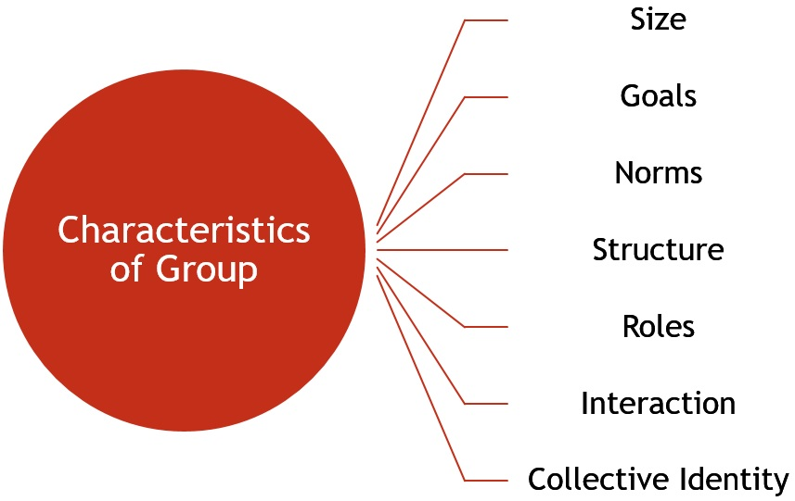

* **Size**: To form a group, it must be having at least two members. Practically, the number of group members ranges from 15 to 20. The more the members in the group, the more complex it is to manage.
* **Goals:** Every group has certain goals, that are the reasons for its existence.
* **Norms**: A group has certain rules, for interacting with the group members.
* **Structure**: It has a structure, based on the roles and positions held by the members.
* **Roles**: Every member of a group has certain roles and responsibilities, which are assigned, by the group leader.
* **Interaction**: The interaction between the group members can occur in several ways, i.e. face to face, telephonic, in writing or in any other manner.
* **Collective Identity**: A group is an aggregation of individuals, which are separately called as members, and collectively called as a group.

Furthermore, a group climate is an emotional setting of the group, that relies on participative spirit, coordination, trust and bonding among the members, open communication and other similar factors.

## [**Types of Groups**](https://businessjargons.com/types-of-groups.html)

[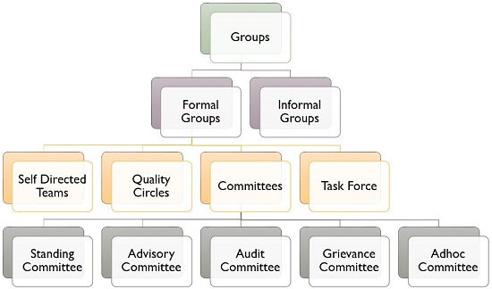](https://businessjargons.com/wp-content/uploads/2018/07/group.jpg)

* [**Formal Groups**](https://businessjargons.com/formal-groups.html): Groups that are formed consciously by the [management](https://businessjargons.com/management.html), with an aim of serving an organizational objective. These are further classified as:
  + **Self-directed teams**: The group of employees which are so authorised to make decisions, on their own, as it is independent and self-governing in nature.
  + [**Quality Circles**](https://businessjargons.com/quality-circle.html): A number of employees classed together belonging to the same field, who meet every week for an hour, to talk about their problems, identify the causes and find out solutions, to take necessary steps in this regard.
  + [**Committees**](https://businessjargons.com/committees.html): An association of people created by the management for different matters to identify and discuss the issues of the company and arrive at a conclusion. It can be:
    - Standing Committee
    - Advisory Committee
    - Audit Committee
    - Grievance Committee
    - Adhoc Committee
  + [**Task force**](https://businessjargons.com/task-force.html): It is a temporary committee, wherein people belonging to different fields are grouped together for the performance of the task.
* [**Informal Groups**](https://businessjargons.com/informal-groups.html): The social and psychological variables operating at the workplace, results in the formation of informal groups. The creation of these groups is spontaneous due to the common interest, social needs, physical proximity and mutual attraction.

Apart from the two broad classifications of the group, they are also divided into the primary groups, secondary groups, membership groups, reference groups and interest groups.

## **Reasons for Group Formation**

[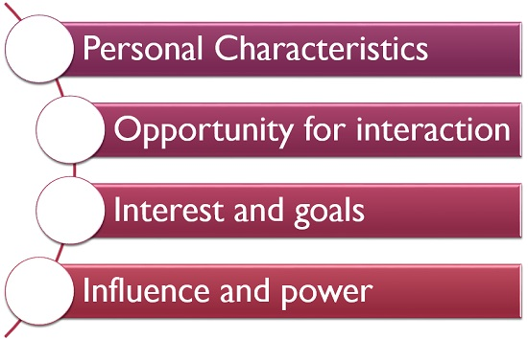](https://businessjargons.com/wp-content/uploads/2018/07/reasons-for-group-formation.jpg)

* **Personal Characteristics**: Individuals with similar beliefs, attitudes and values are more likely to form groups.
* **Opportunity for interaction**: If the employees of an organization, are given an opportunity to interact with one another, they find that they have many things similar, which also creates a group.
* **Interest and goals**: When individuals share common interest and goals, it requires cooperation and coordination for its achievement, which also results in the formation of groups.
* **Influence and power**: Last but not the least, a group has more influence and power, as compared to an individual, which also promotes its formation.

In general, groups are created out of individual need satisfaction, which can be personal, social or economical. Meaning that the members need to associate with the group in order to fulfil their basic needs.

**[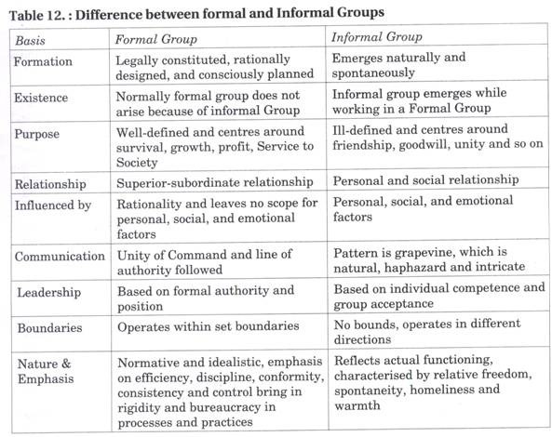](https://cdn.yourarticlelibrary.com/wp-content/uploads/2013/08/clip_image0142.jpg)**

**Process/Stages of Group Development/Evolution:**

Group Development is a dynamic process. How do groups evolve? There is a process of five stages through which groups pass through. The process includes the five stages: forming, storming, forming, performing, and adjourning.

**Forming:**

The first stage in the life of a group is concerned with forming a group. This stage is characterized by members seeking either a work assignment (in a formal group) or other benefit, like status, affiliation, power, etc. (in an informal group). Members at this stage either engage in busy type of activity or show apathy.

**Storming:**

The next stage in this group is marked by the formation of dyads and triads. **Members seek out familiar or similar individuals and begin a deeper sharing of self**. Continued attention to the subgroup creates a differentiation in the group and tensions across the dyads / triads may appear. Pairing is a common phenomenon. There will be conflict about controlling the group.

**Norming:**

The third stage of group development is marked by a more serious concern about task performance. The dyads/triads begin to open up and seek out other members in the group. Efforts are made to establish various norms for task performance.

Members begin to take greater responsibility for their own group and relationship while the authority figure becomes relaxed. Once this stage is complete, a clear picture will emerge about hierarchy of leadership. The norming stage is over with the solidification of the group structure and a sense of group identity and camaraderie.

**Performing:**

This is a stage of a fully functional group where members see themselves as a group and get involved in the task. Each person makes a contribution and the authority figure is also seen as a part of the group. Group norms are followed and collective pressure is exerted to ensure the Process of Group effectiveness of the group.

The group may redefine its goals Development in the light of information from the outside environment and show an autonomous will to pursue those goals. The long-term viability of the group is established and nurtured.**[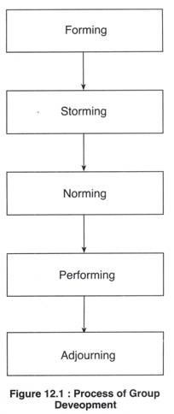](https://cdn.yourarticlelibrary.com/wp-content/uploads/2013/08/clip_image00231.jpg)**

**Adjourning(closure)**

In the case of temporary groups, like project team, task force, or any other such group, which have a limited task at hand, also have a fifth stage, This is known as adjourning.

The group decides to disband. Some members may feel happy over the performance, and some may be unhappy over the stoppage of meeting with group members. Adjourning may also be referred to as mourning, i.e. mourning the adjournment of the group.

The readers must note that the four stages of group development mentioned above for permanent groups are merely suggestive. In reality, several stages may go on simultaneously.

**[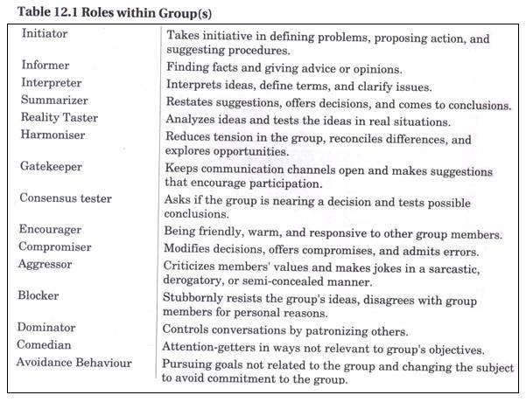](https://cdn.yourarticlelibrary.com/wp-content/uploads/2013/08/clip_image00618.jpg)**

**[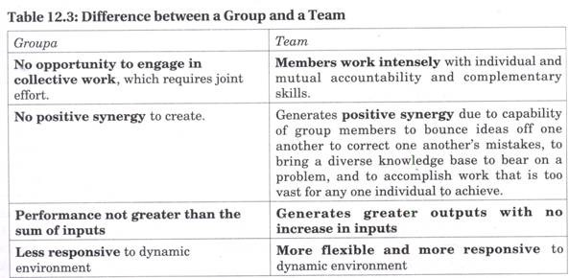](https://cdn.yourarticlelibrary.com/wp-content/uploads/2013/08/clip_image0107.jpg)**

Group Properties: Roles, Norms, Status, Size, Cohesiveness & Diversity

Work groups have different properties and individual behavior within the group as well as the performance of the group itself is shaped by these properties.

Roles – Our view of how we are supposed to act in a given situation is driven by role perception, role expectations and role conflicts, where in role perception is an individual’s perception of the behavior expected in his role, Role expectation is the expectation of other employees from an individual in a given role and Role Conflicts is the conflict which employees face when they play different roles in the organization as well as outside the organization which have direct conflict Roles – Our view of how we are supposed to act in a given situation is driven by role perception, role expectations and role conflicts, where in role perception is an individual’s perception of the behavior expected in his role, Role expectation is the expectation of other employees from an individual in a given role and Role Conflicts is the conflict which employees face when they play different roles in the organization as well as outside the organization which have direct conflict

Norms – Groups have established norms of behavior. Most of these norms are unwritten and not formal ones, but they are meticulously followed by members in the group. Conformity to group norms and pressures applied on group members to conform to these norms. Deviant workplace behavior is another common organizational norm which gets violated often in organizations. Norms – Groups have established norms of behavior. Most of these norms are unwritten and not formal ones, but they are meticulously followed by members in the group. Conformity to group norms and pressures applied on group members to conform to these norms. Deviant workplace behavior is another common organizational norm which gets violated often in organizations.

Status – Higher status individuals are often given more freedom to deviate from norms than other group members. Hence status tends to get derived from one of the three sources: power a person wields over others, person’s ability to contribute to a group’s goals, an individual’s personal characteristics norms than other group members. Hence status tends to get derived from one of the three sources: power a person wields over others, person’s ability to contribute to a group’s goals, an individual’s personal characteristics

Size – size of the group also affects group behavior. Social loafing is the tendency for individuals to expend less effort when working collectively than alone. Research proves that the productivity of the group is not equal to the sum of the productivity of the individuals in the group. size of the group also affects group behavior. Social loafing is the tendency for individuals to expend less effort when working collectively than alone. Research proves that the productivity of the group is not equal to the sum of the productivity

Cohesiveness – the degree to which members are attracted to each other and motivated to stay in the group. High Cohesiveness and high performance norms brings high productivity, but if cohesiveness is high & performance norms are low, than productivity will also be low. At the same time, if cohesiveness is low and performance norms are high, productivity will be high even though it may not be to the scale of high cohesive and high performance norm group.

Diversity- research points at benefits as well as costs from group diversity. When the group is very diverse, the surface level characteristics can take over and influence group behavior and bring group conflict especially in the early stages of a group’s tenure. Tenure diversity has no direct impact on performance if human resource practices are in place. But the difference is in the leaders who can get the group to focus on the task at hand and encourage group learning.